Exception Handling
There are mainly three types of exceptions.
- Unchecked Exception
- Checked Exception
- Error
1.Unchecked Exception
An Exception which does not check by compiler but check by JVM such exception comes under unchecked Exception.
If an unchecked exception occurs within the program, will the program compile?
Yes
Ex: Aritimetic Exception, ArrayIndexOutOfBound
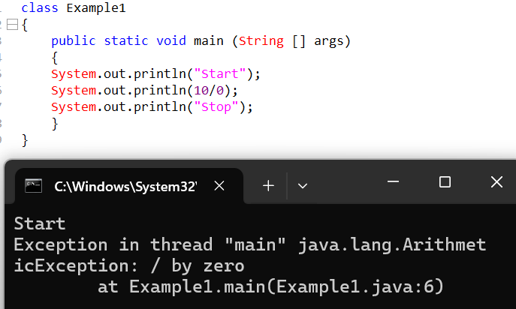
In an unchecked exception, will the program execute?
No
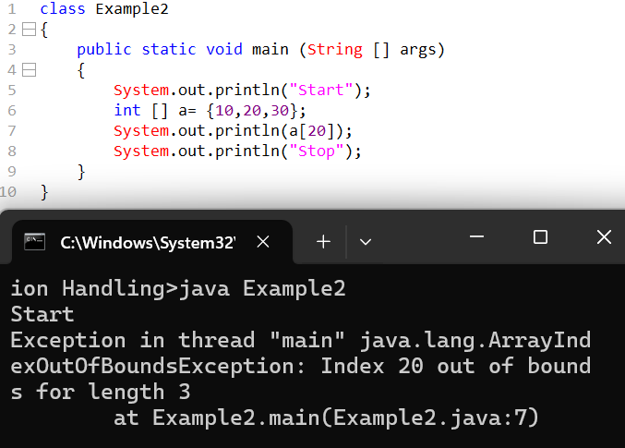
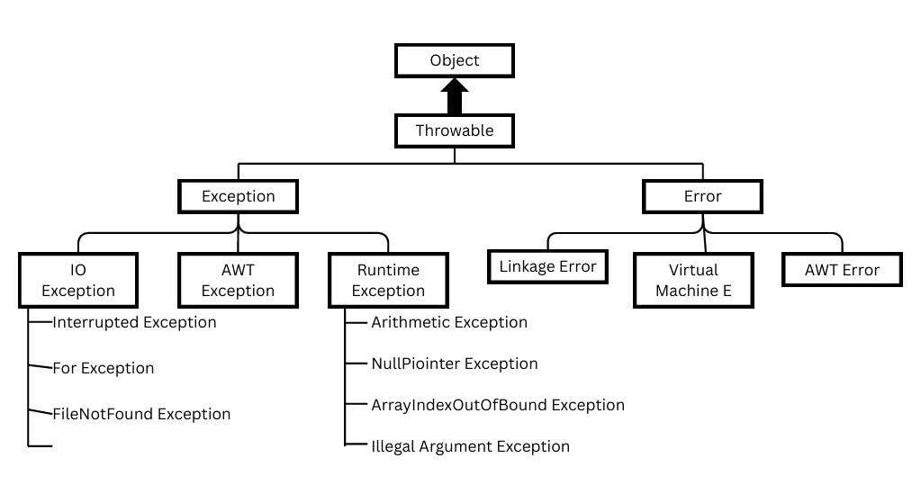

Checked Exception
An Exception which is checked by the compiler and it is not checked by the JVM such exception is called Checked Exception.
IMP
When a checked Exception occurs, Will the program compile.
No
Ex: InterruptedExecption
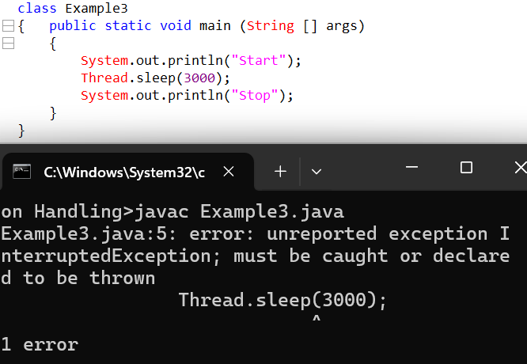
There are multiple types of exceptions defined by java.

1.What is root to all java classes?
It is the Object class.
2.What is root to all exception classes?
Throwable
3.What do you mean by fully checked Exception and partially checked Exception.
  - Fully Checked Exception:
If the root class is checked and all it’s child class are checked such an Exception is called as fully checked exception.
Ex: IO exception
  - Partially Checked Exception:
If the root class contains multiple child classes, some of the child class, is checked and some of the child class is unchecked such an exception is called as partially checked exception.
Ex: Exception, Throwable

Exception Handling
What is Exception Handling?
It is a process which includes
- It should lead to normal termination.
- It also incudes all statement should get executed.
How do we handle exceptions?
To handle exceptions there are two approaches
- With help of try catch block.
- With help of throws keyword.
Try-catch
Syntax: Try
{}
Catch()
{}
Try: In the try block only mention that statement which will raise an exception but, in the catch block write those statements which can provide alternative solution.
- Exception internally is treated as classes
- Whenever an exception is generated, it means that an object gets created to access that object the catch block uses reference variable of same type.
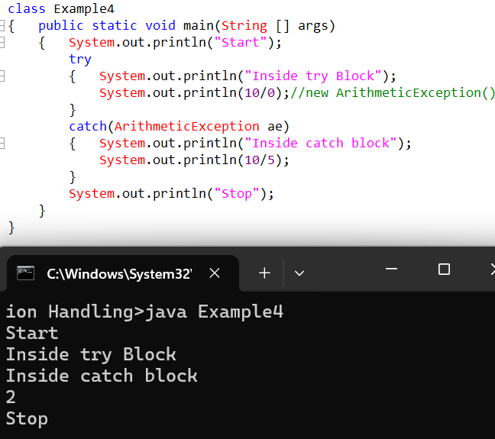
If the exception is raised within try block only then the control will go to catch block if the exception is not raise in try block the control will never go to catch block again.
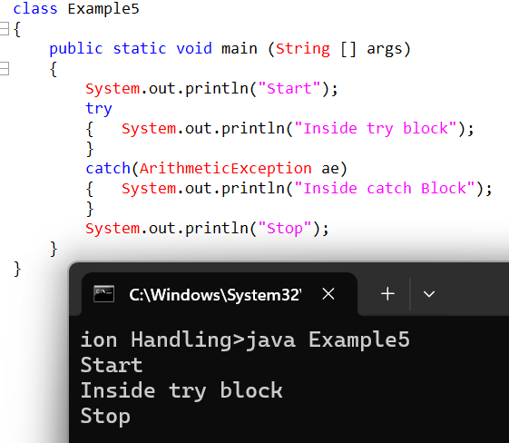
Independent try blocks are not allowed
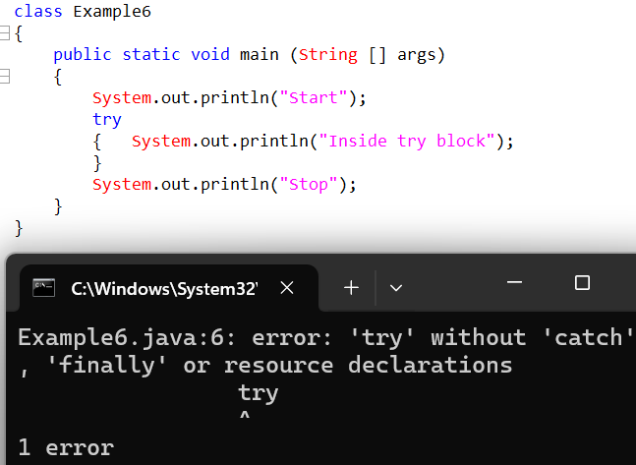
If an exception is raised of a particular type then it should be caused by same type, but if it is called by different type it will lead to abnormal termination
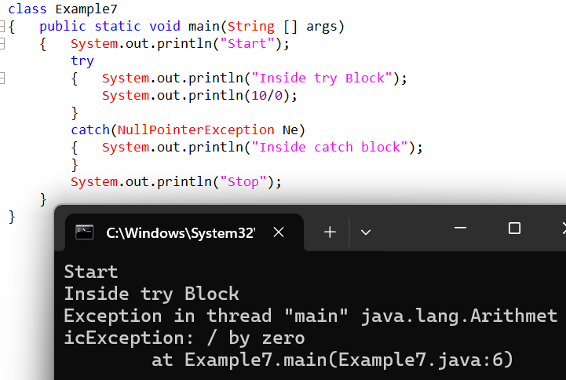
When the control come out of try block it will go to catch block, once control comes out of try block it will never go again to try block. Never use generic statements within the try and catch block never use statements after the exception statement.
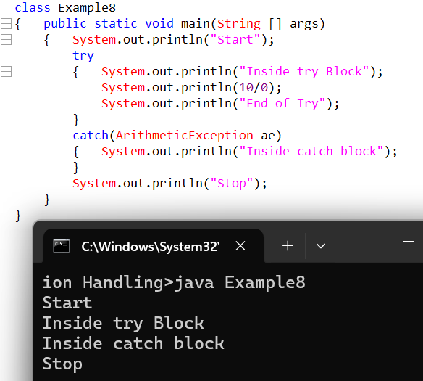
It will not matter in catch block whatever exception is written mentioned under the situation the exception is into raised but it will matter in catch block type of exception only when the exception is raised.
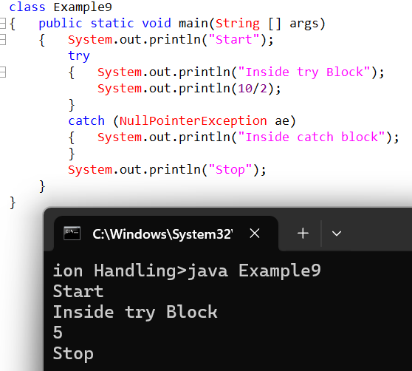
Exception raised in try block will be handled by catch block, but if an exception is raised with the catch block it will lead to abnormal termination.
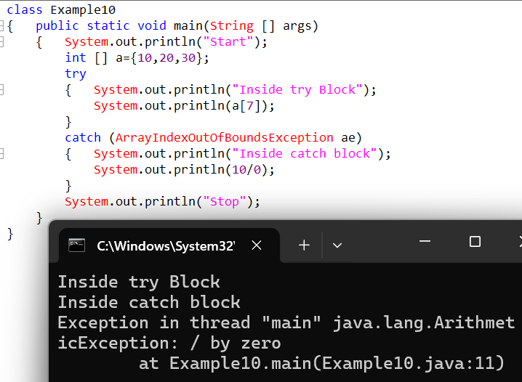
A try block can raise any type of exception at any point of time it will raise only one type of exception.
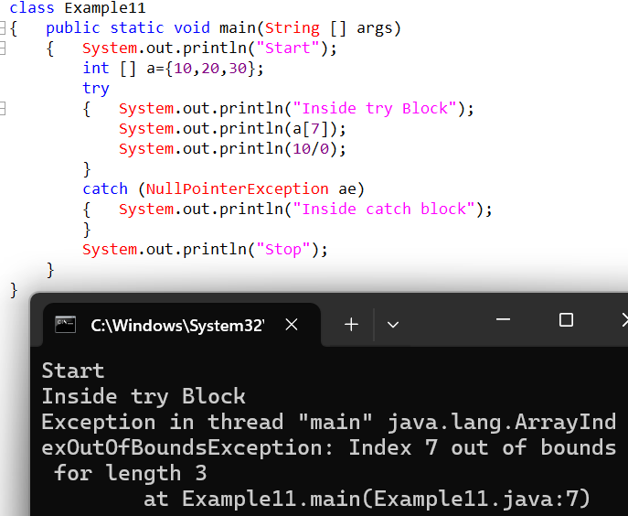
It is possible to have one try catch block.
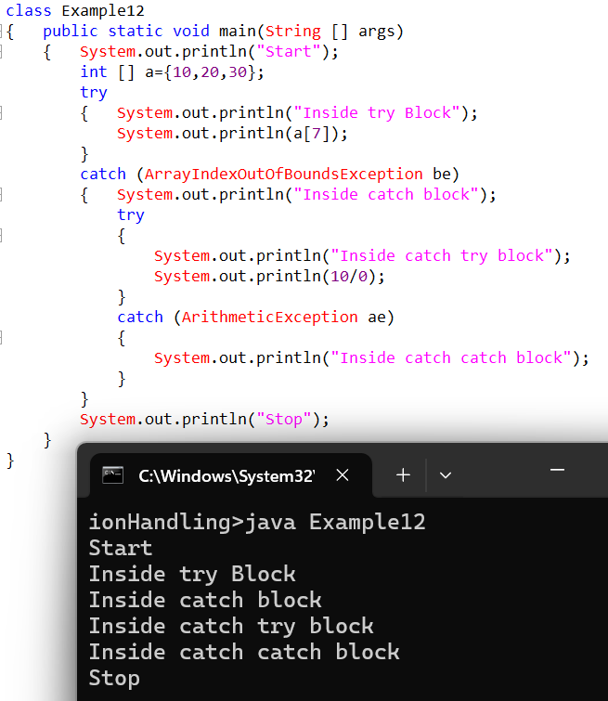

- It is possible to have 1 try block and multiple catch block.
- The one type of try block are obtain contain different type of exception but to handle that different type of exception we required a different catch block.
- As seen in ex 13 based on two types of exception we have two catch blocks.
- Similarly based on 10 exceptions have create to catch block and based on 50 exception we have to create 50 catch blocks.
- Out of which any point of time it will execute only one catch block due to this remainng 49 block will never get executed.
- Because of 49 block not getting executed the code length has will been increase due to impact.
Because of the 49 blocks not getting executed the code length has still been increased due to which it will have an impact on the execution of the program

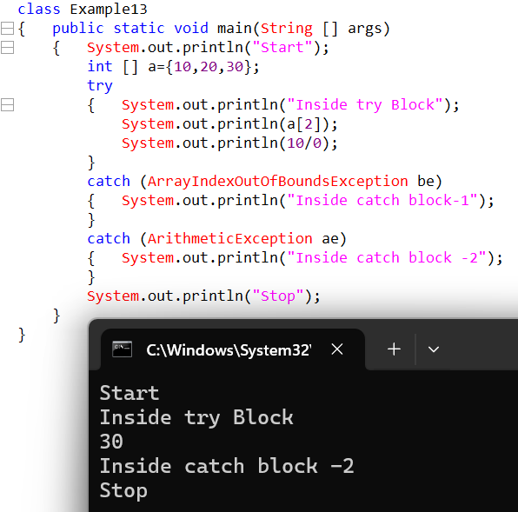

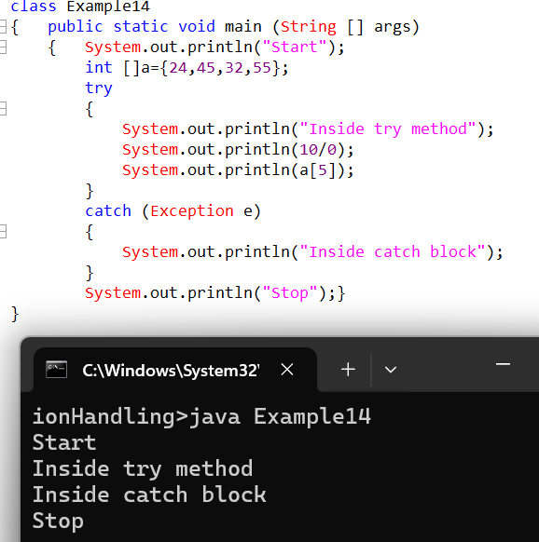

Whenever we print normal class reference variable it prints the address but whenever we print exception type reference variable it doesn’t print address it prints the exception info Why?
ToString() is overridden in exception classes
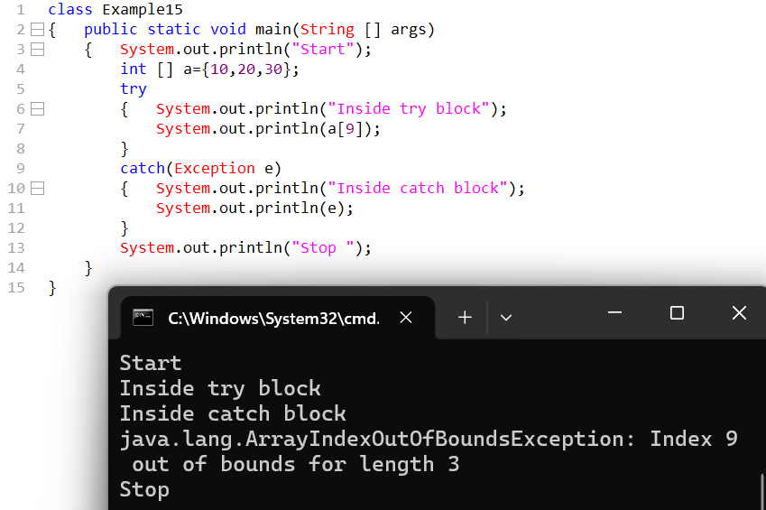

How many ways are there to print exception info there are ways to print exception info
There are 3 ways to print exception info.
1.public Sting toSting()
2.public String getMessage()
3.public void printStackTrace()
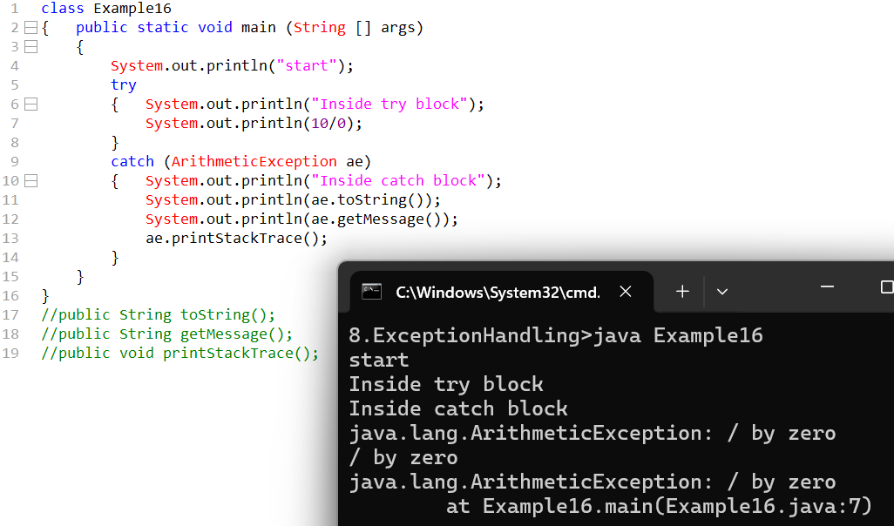
Which is the default method which gets called to print the exception info
printStackTrace()
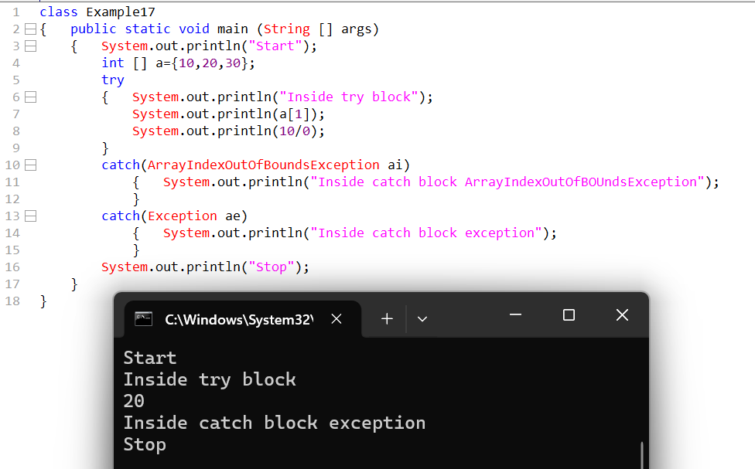

We can use multiple catch blocks but the order of those catch blocks can be from child to parent.
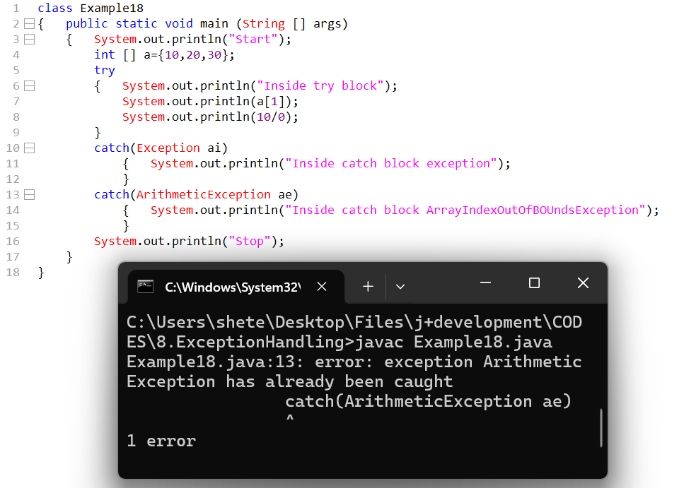
- Whenever exception is raised exception will always propagate or will first look it into immediate catch block and propagate down to bottom
- If the first catch block is unable to handle the exceptions then it will move on to the next catch blocks.
- If the first catch block handles all the exception then the exception will never propagate to the next Catch blocks.
- We cannot use multiple catch blocks if the order is from parent to child.
We cannot use statements after the try and before the catch .
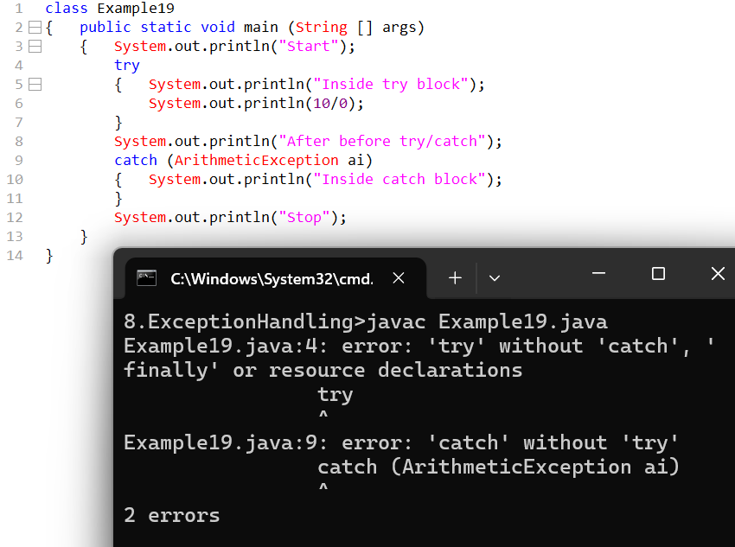
Try
{ try{}
Catch{}
}
Catch
{ try{}
Catch{}
}
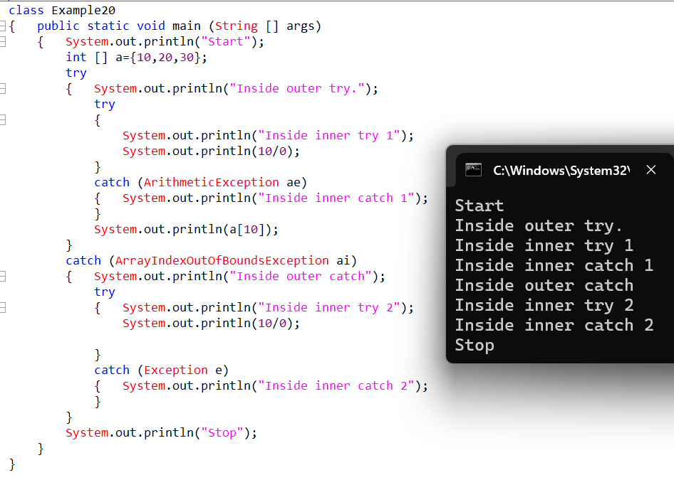
Both checked and unchecked exceptions can be handles with help of try catch blocks

Finally Block
Finally block are written after catch block.
The finally block is used to execute important code whether an exception occurs or not.
Main Use of finally Block:
Used for cleanup code such as:
- Closing file
- Closing database connection
- Closing scanner
- Releasing resources
- Important final statements
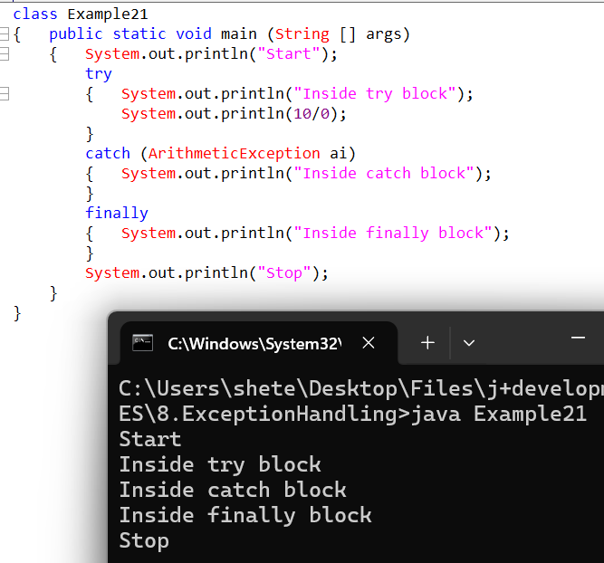

If the controller goes to try block then finally block will always get executed.
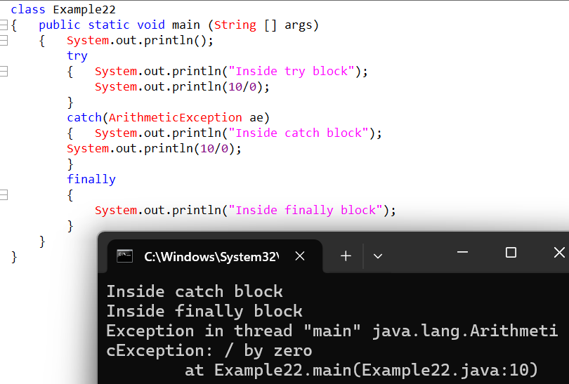
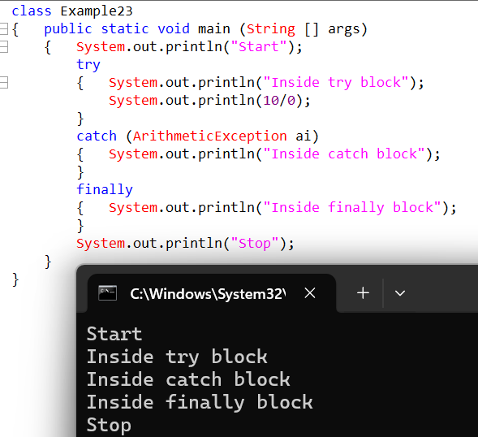
We cannot use independent try blocks either we need to use try with catch or we need to us try with finally.
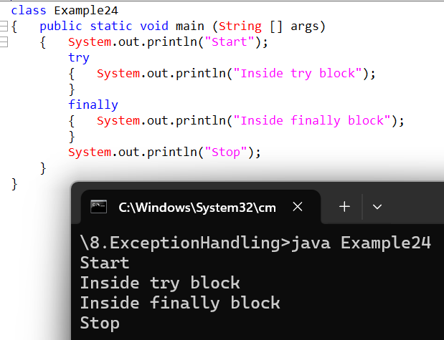
Whenever exception is raised by the try block it cannot be handled by the finally block this will lead to abnormal termination.
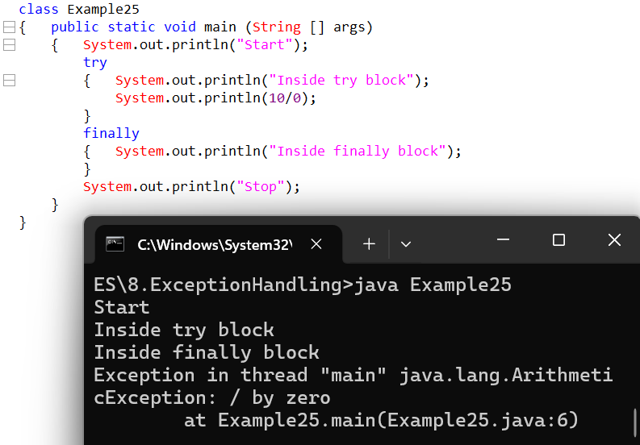
If the exception is raised within the finally block it will lead to abnormal termination.
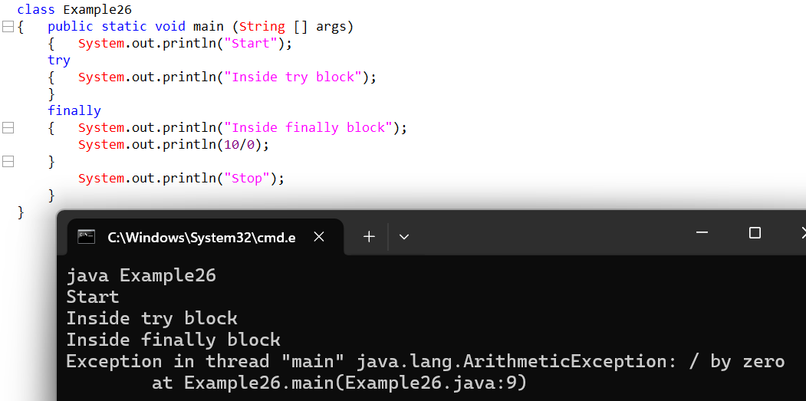
But it can be handled using another try-catch block
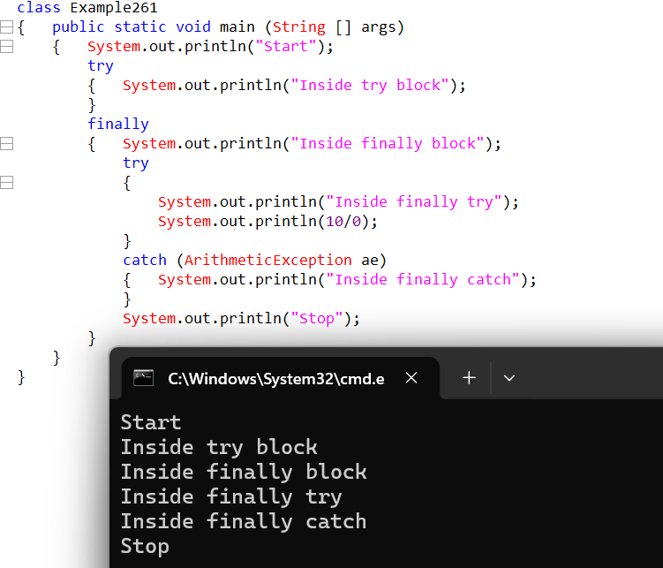
With help of system.exit method finally block will never get executed
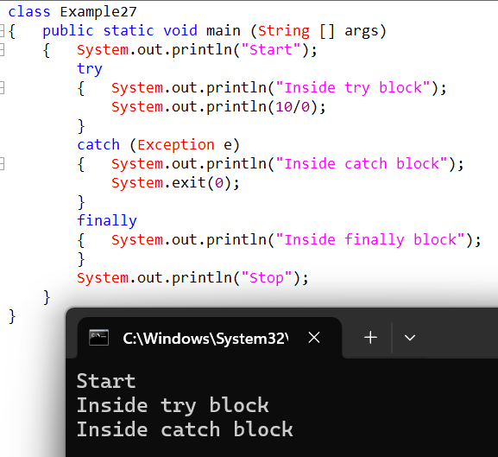
If the exception is raised outside the try block then this will lead to force JVM shut down when in the finally block will never get executed.
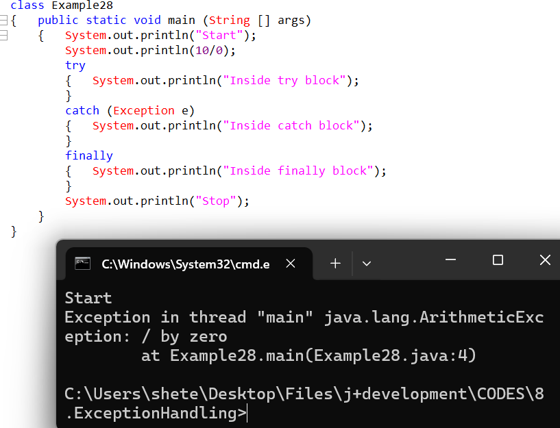

Imp note only when the control goes to try block the finally block get executed
FLOW OF THE TRY-CATCH Block.
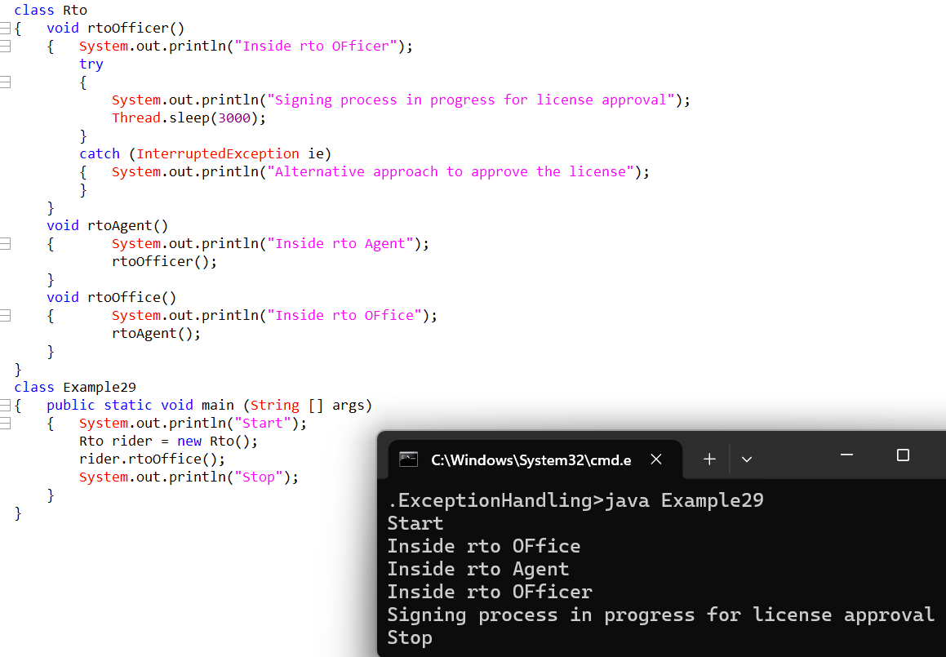
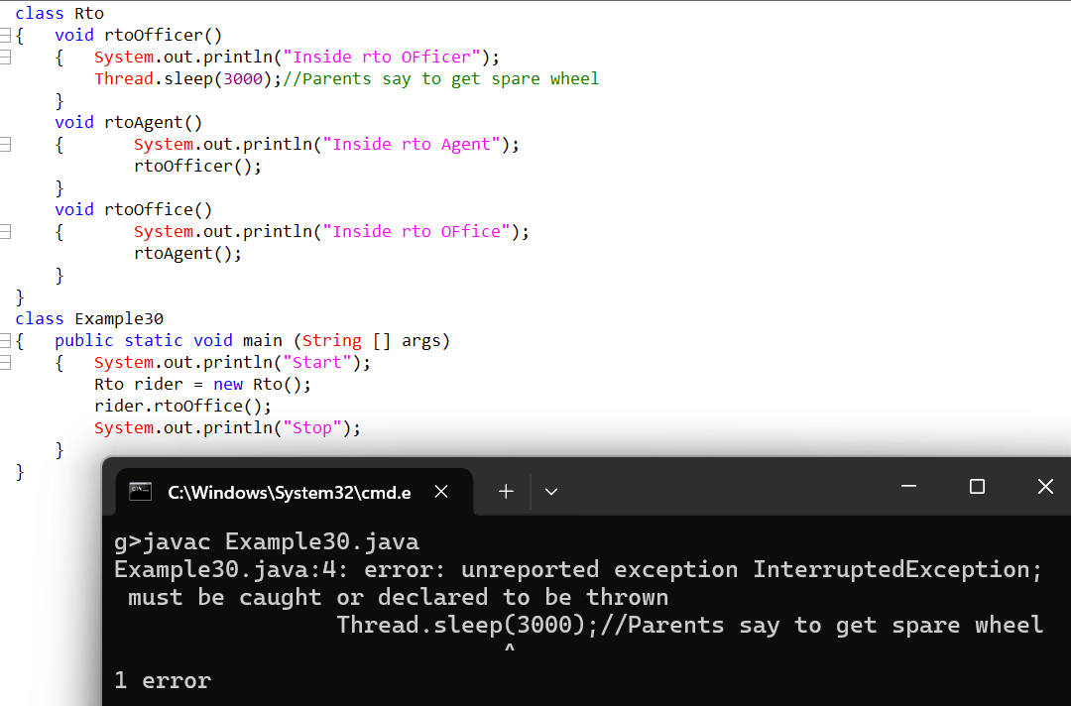

Throws keyword
Throws keyword is used in method signature to declare possible exception.
The throws keyword will not handle the exception, but it will delegate the exception to the immediate caller method
To handle the exception there is only one approach that is try catch
Compilation exceptions are treated as warnings compilation exceptions can-not be handled during compilation time it can only be handled during run time.
Exception can be generated during compile time or run time but it will only be handled during the runtime execution of program.
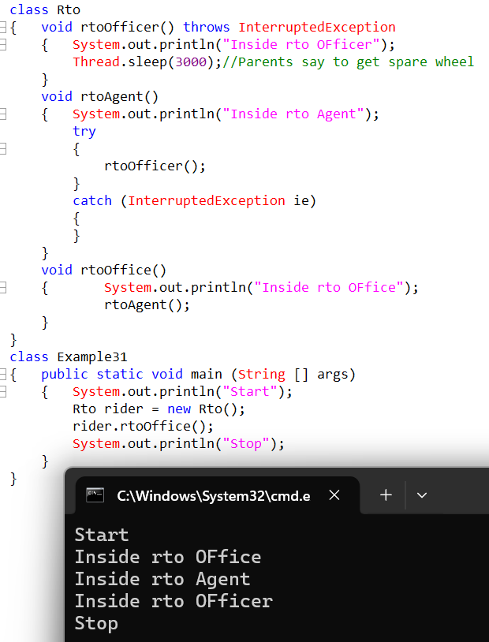
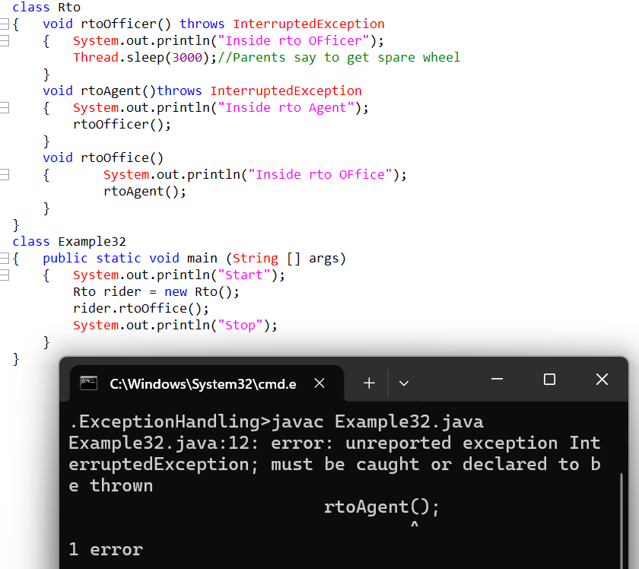
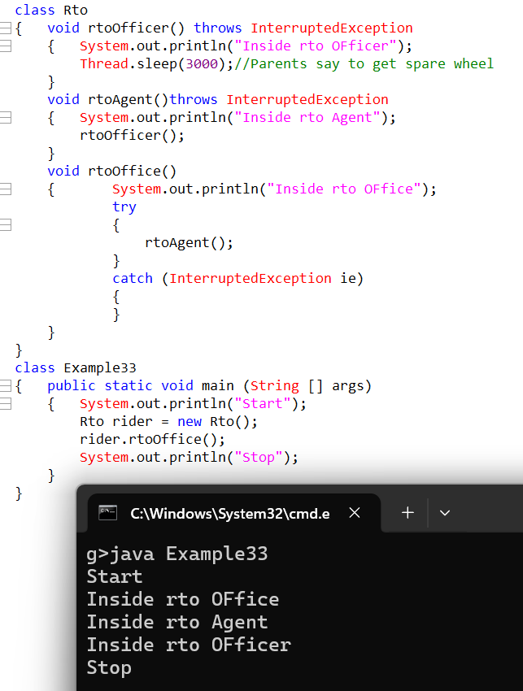
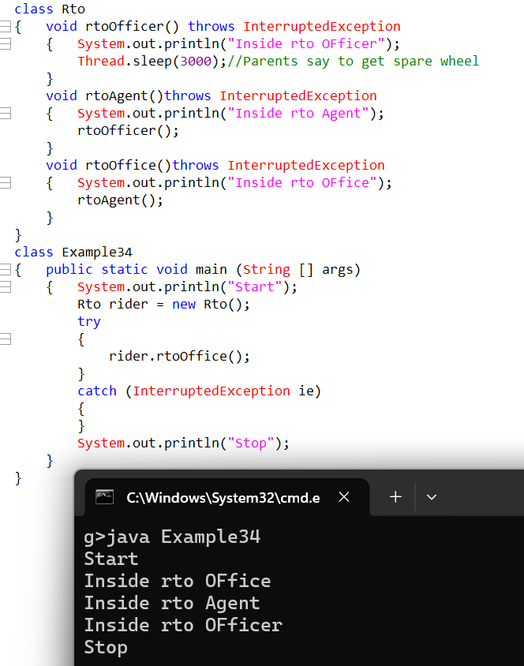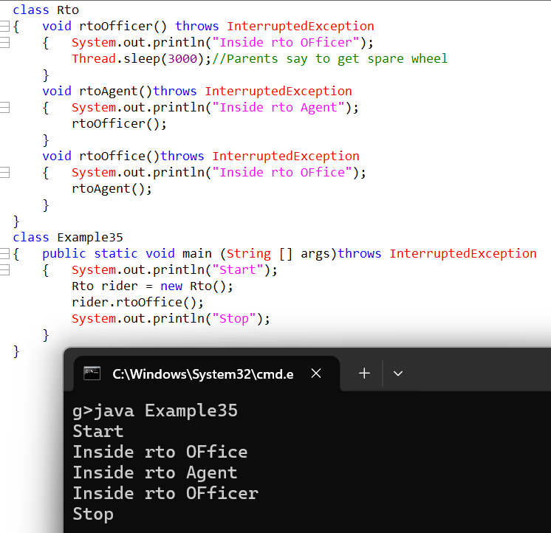

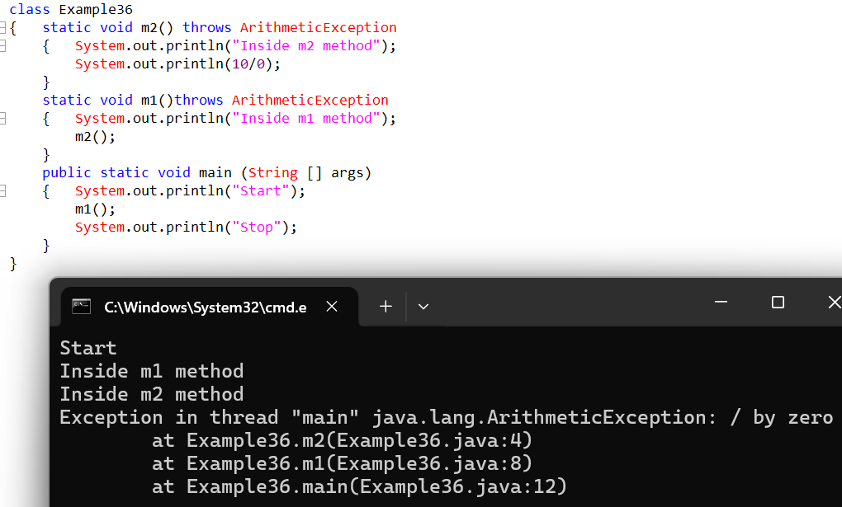
Unchecked exception cannot be delegated only checked exception can be delegated

38
Throws keyword will be responsible not able to throw one exception but will be able to throw multiple exceptions.
Try Catch | Throws
- The try catch block can handle the exception.  - Try catch block is used at implementation level.  - The try catch block can generate different type of exception but any point it can only raise one exception.  - Try catch can be used at method constructor or block level.  - Try catch block can handle both checked as well as unchecked exception. | - Throws keyword can delegate exception cannot handle exception  - Whereas throws keyword used at declaration level.  - Throws keyword can either throw minimum one exception or can throw multiple exceptions.  - Throws can be used at method and constructor level.  - Throws keyword can handle only checked exception.

q

Throw
The Throw keyword is responsible to customize predefined exception info.
- To customize predefined exception information, we go for throw keyword
- The throw keyword is also responsible to instruct the JVM to treat the object creation as a type of Exception.
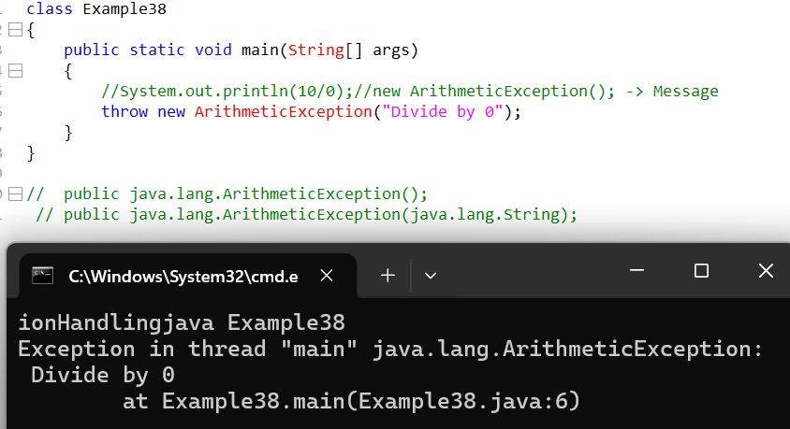
Whenever we create an object of exception class java will treat that as normal object creation, hence to inform JVM it is not a normal object creation it is type of an Exception we use Throw keyword.
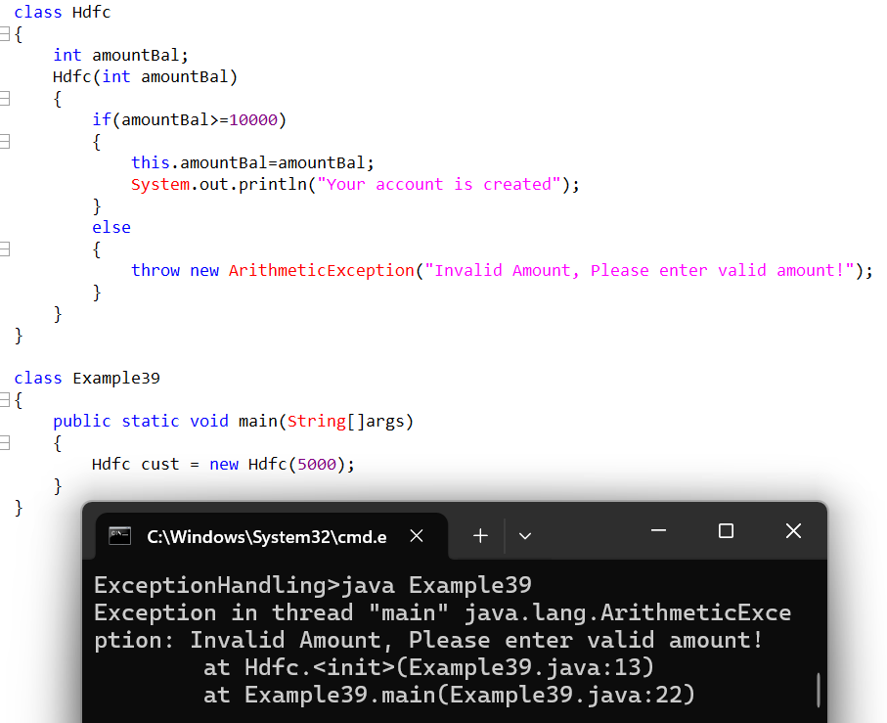

Custom Exceptions
Exceptions can be mainly categorized into two types
- Pre-defined Exceptions
- User-defined Exceptions
Pre-defined Exceptions - Exceptions created by oracle or java
User-defined Exceptions - Exceptions created by user.
User-defined Exceptions mainly can be categorized into two types.
- Checked Exception.
- Unchecked Exception.
Custom- checked exception can further be categorized into two types zero argument constructor and augmented constructor.
If we have to created custom checked exception then we have to extend Exception class.
Custom checked zero argument exception
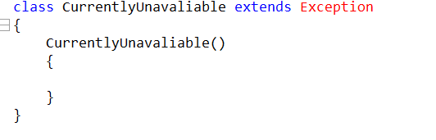
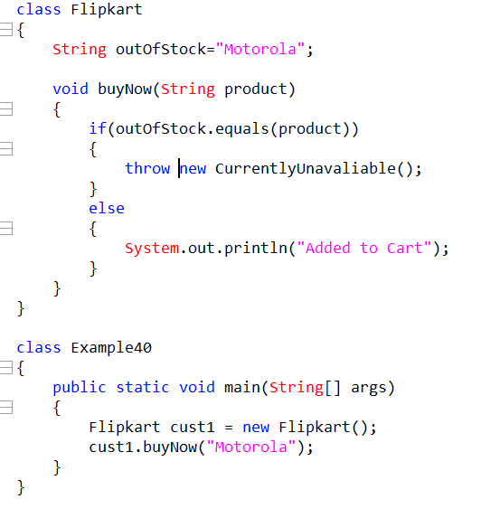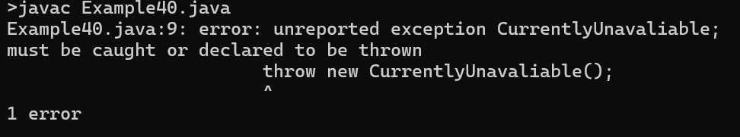

Custom checked argument exception
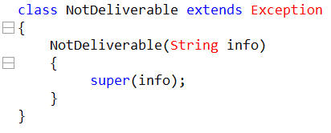
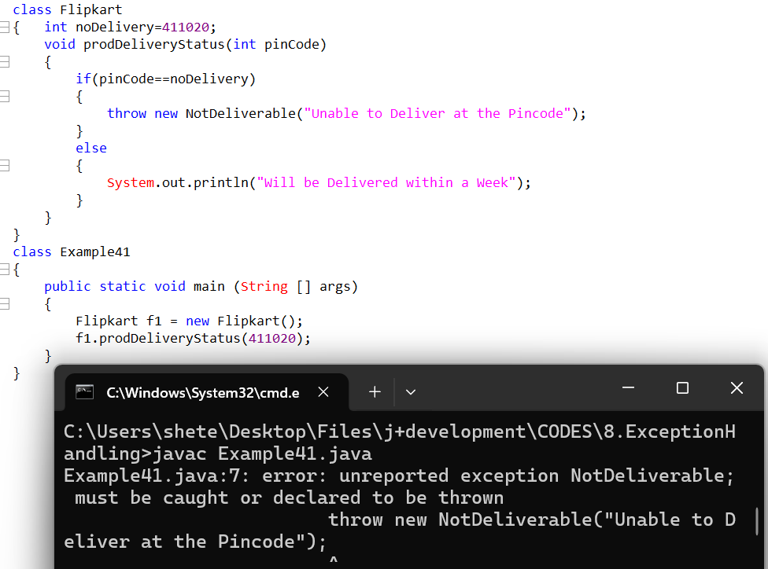

To create an unchecked exception respective class has to extend RuntimeException.
Custom unchecked zero argument Exception
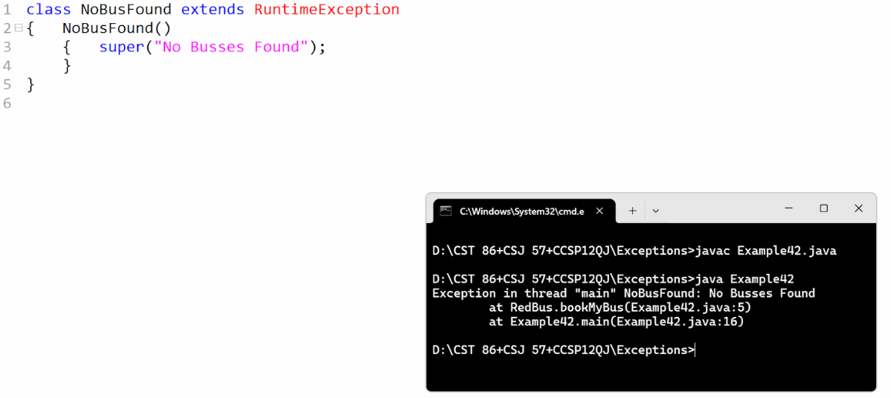
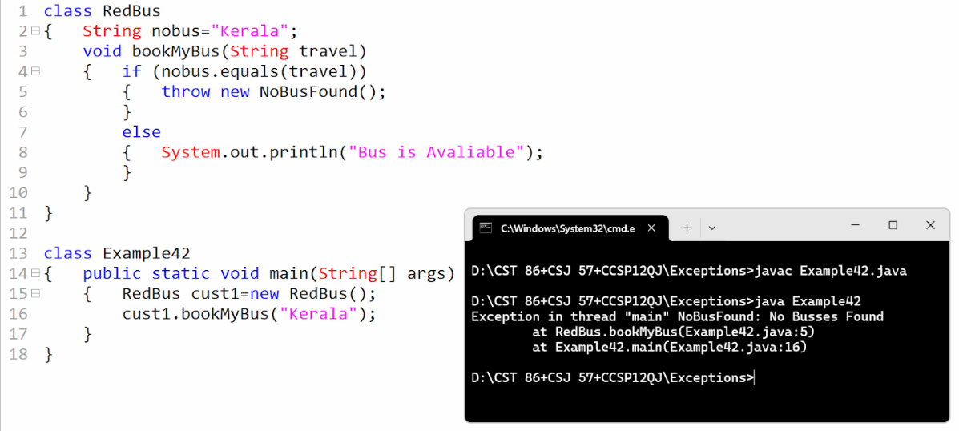

Custom unchecked argument Exception
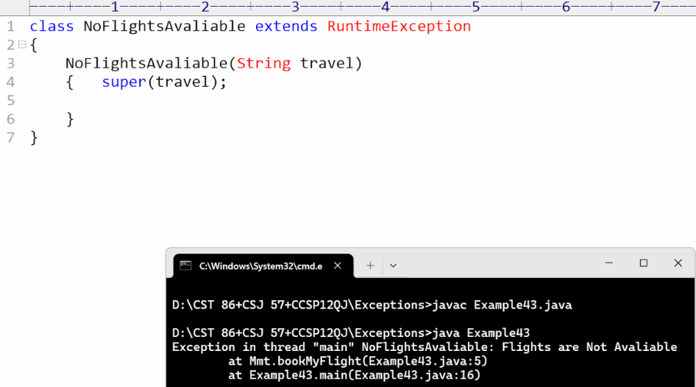
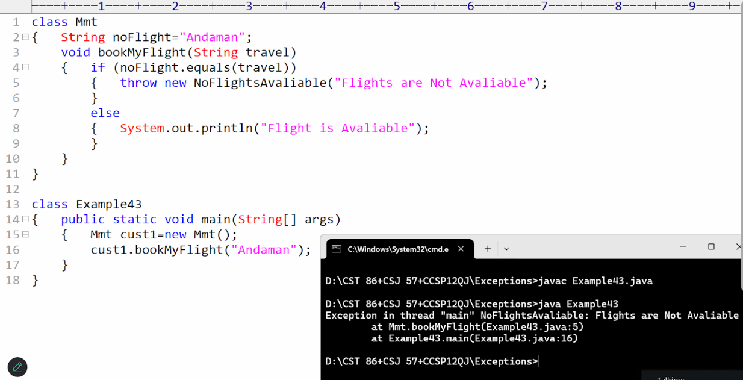

Errors
Errors of type Exception can not be handeled.
